***SPORTY SHOES PROJECT***

***BY***

***ABHISHEK JANA***

***Problem Statement:***

Sporty Shoes is a company that manufactures and sells sports shoes. They have a walk-in store, and now, they wish to launch their ecommerce portal sportyshoes.com.

You’re asked to develop a prototype of the application. It will be then presented to the relevant stakeholders for budget approval. Your manager has set up a meeting where you’re asked to do the following:

● Presenting the specification document which has the product’s capabilities, appearance, and user interactions  
● Setting up Git and GitHub account to store and track your enhancements of the prototype   
● Explaining the Java concepts used in the project   
● Discussing the generic features of the product:  
● There will be an admin to manage the website. An administrator login will be required to access the admin page.

**The admin should be able to change his password if he wants, he should be able to:**

● Manage the products in the store including categorizing them  
● Browse the list of users who have signed up and be able to search users  
● See purchase reports filtered by date and category

***Sprints and the User Stories:***

***Sprint-1: (One week)***

• ***User Story-1 :***  As an Administrator, I want to have an option to create Users, so that i can set up a master list of Users

• ***User Story-2 :***  As an Administrator, I want to have an option to create Products, so that i can set up a master list of Products

• ***User Story-3 :***  As an Administrator, I want to have an option to view Users, so that i can view a User by Id and also a list of Users.

• ***User Story-4 :***  As an Administrator, I want to have an option to view Products, so that i can view a Product by Id

• ***User Story-5 :***  As an Administrator, I want to have an option to view Products, so that i can view a list of Products.

• ***User Story-6 :*** As an Administrator, I want to have an option to view Users, so that i can view a User by Id..

• ***User Story-7 :*** As an Administrator, I want to have an option to view Users, so that i can view a list of Users.

• ***User Story-8 :*** As an Administrator, I want to have an option to view Products, so that i can view a Product by Category.

• ***User Story-9 :*** As an Administrator, I want to have an option to update Users, so that i can modify a User by Id.

• ***User Story-10 :***  As an Administrator, I want to have an option to update Products, so that i can modify a Product by Id.

***Sprint-2:(one week)***

• ***User Story-1 :*** As an Administrator, I want to have an option to delete Users, so that i can remove Users whenever they are not required.

• ***User Story-2 :*** As an Administrator, I want to have an option to delete Products, so that i can remove Products whenever they are not required.

• ***User Story-3 :*** As an Administrator, I want to have an option to map Products to Users via purchase, so that i can map Products to Users whenever the User purchases Products.

• ***User Story-4 :*** As an Administrator, I want to have an option to reset or change my password, so that i can change or update password whenever required.

• ***User Story-5 :*** As an Administrator, I want to have an option to view purchase report by Date, so that i can see the purchase reports for analysis.

• ***User Story-6 :*** As an Administrator, I want to have an option to view purchase report by Category, so that i can see the purchase reports for analysis by Category.

***Jira Sprint– Agile Scrum :***

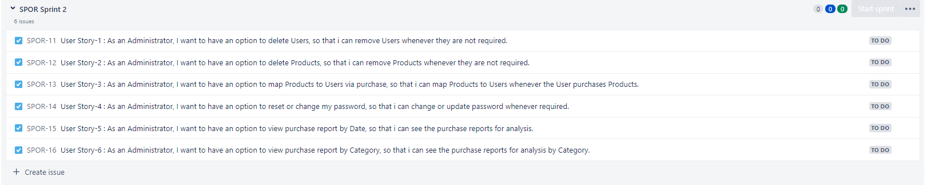

***Tools used in the Project:***

|  |  |
| --- | --- |
| ***Programming Language and related*** | ***Java*** |
| ***IDE*** | ***Eclipse*** |
| ***Database*** | ***H2 – persistent DB*** |
| ***Version Control System*** | ***Git & GitHub*** |
| ***Software Development Methodology*** | ***Agile - Scrum - Jira*** |

***Hierarchy of codes developed:***

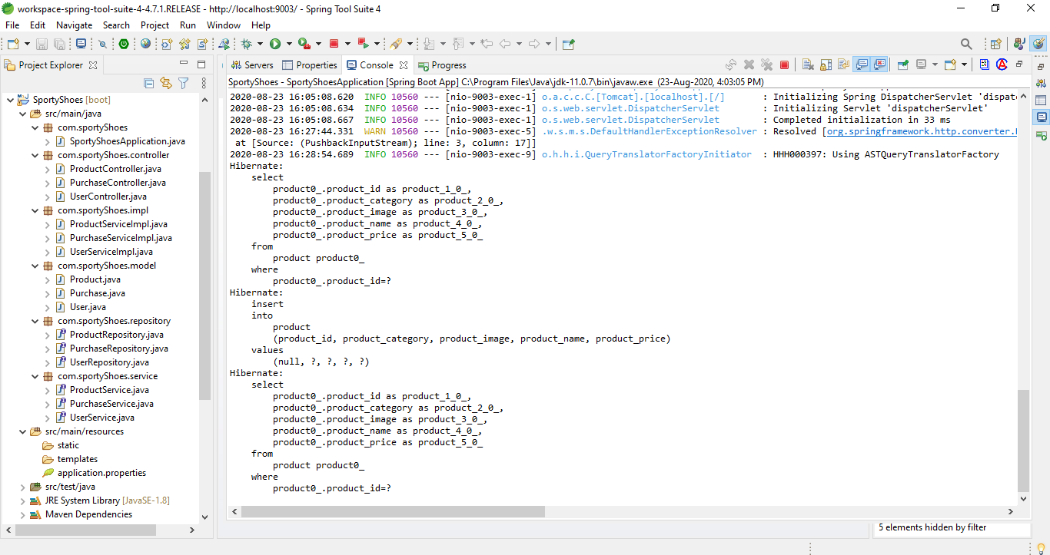

***Exception Handling:***

Some of the exceptions and errors are handled, so that the application won’t close, exit or throw an exception.

***Entity and Tables:***

1. User
2. Product
3. Purchase
4. Cart

***Tables created in Database:***

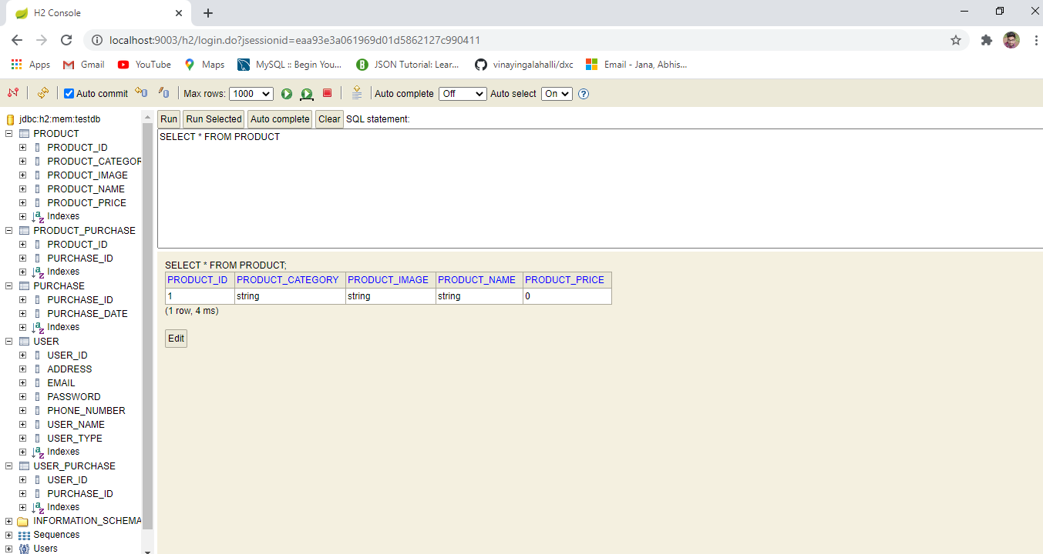

***Option to create/Read/Update/Delete the User and Products:***

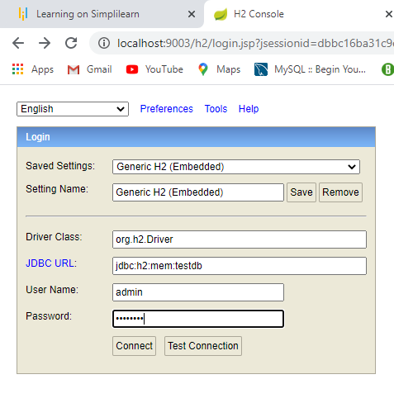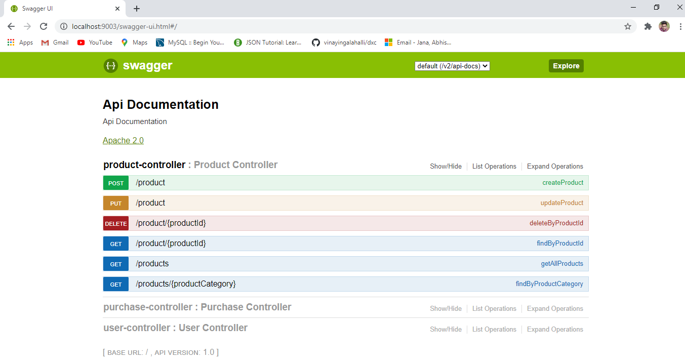

***Access using-*** <http://localhost:9003/h2> **access using- http://localhost:9003/swagger-ui.html**

***Username-admin***

***Password-password***

***Git Screenshots:***

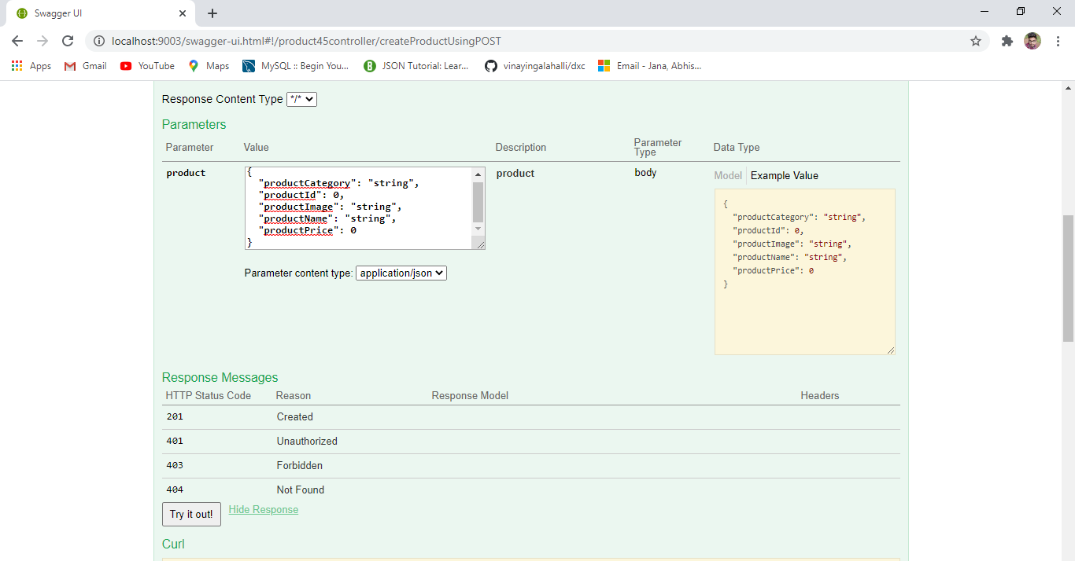

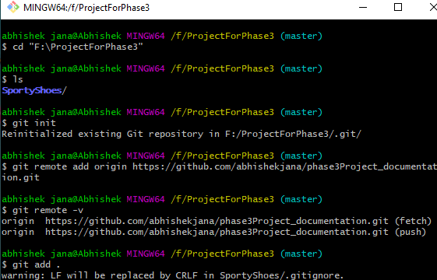

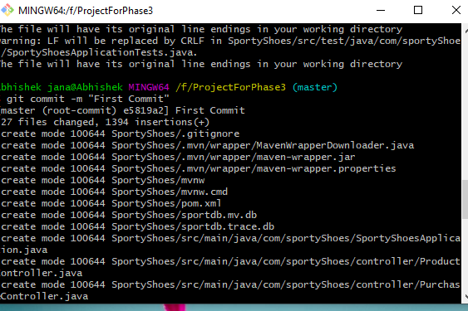

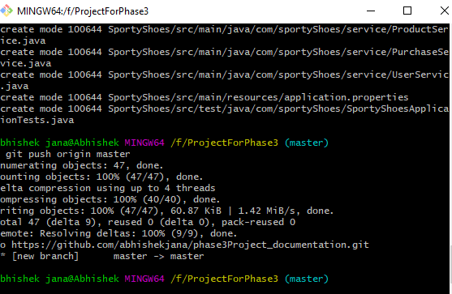

***GitHub Repository:***

***All the project related files are uploaded to the below GitHub repository.***

**Git hub link- https://github.com/abhishekjana/phase3Project_documentation.git**